Category 2 - Intermediate Questions

1. For each OPO, calculate the total number of referrals per hospital_id (patient table) and
identify the hospital with the highest referral count. Use a window function to rank
hospitals within each OPO.

Reason
It identifies which hospitals contribute the most donor referrals for each OPO. Using a
window function to rank hospitals allows us to systematically compare performance
across hospitals.

optimization technique
Using a Window Function (ROW_NUMBER) instead of multiple queries
This optimization technique helps in following ways:
1.It ranks hospitals within each OPO in one single query.
2.It avoids writing separate queries for each OPO.
3.It avoids using complex subqueries or temporary tables.
4.It processes ranking efficiently inside the database engine.
How this improves performance
1.The database calculates ranking in one pass.
2.No repeated scans of the table.
3.Less complex logic.
4.Faster and cleaner execution.
Query
WITH hospital_referrals AS (
SELECT
p.opo,
p.hospital_id,
COUNT(p.patient_id) AS total_referrals
FROM patient p
GROUP BY p.opo, p.hospital_id
),
ranked_hospitals AS (
SELECT
opo,
hospital_id,
total_referrals,
ROW_NUMBER() OVER (PARTITION BY opo ORDER BY total_referrals DESC) AS rank_within_opo
FROM hospital_referrals
)
SELECT *
FROM ranked_hospitals
WHERE rank_within_opo <= 3
ORDER BY opo, rank_within_opo;

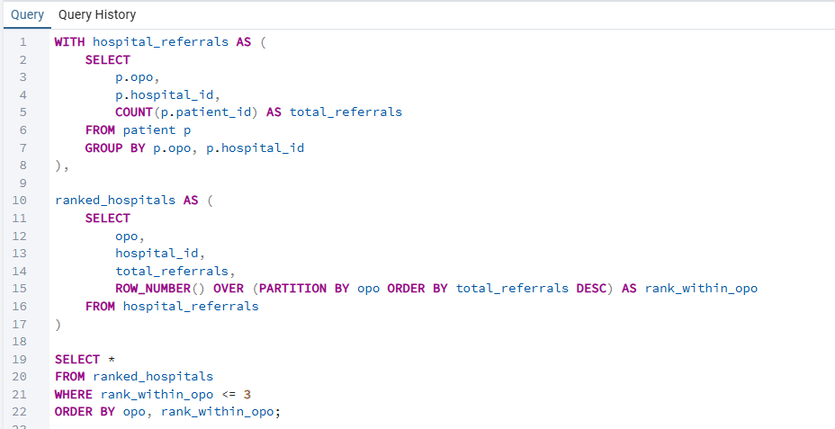

Output
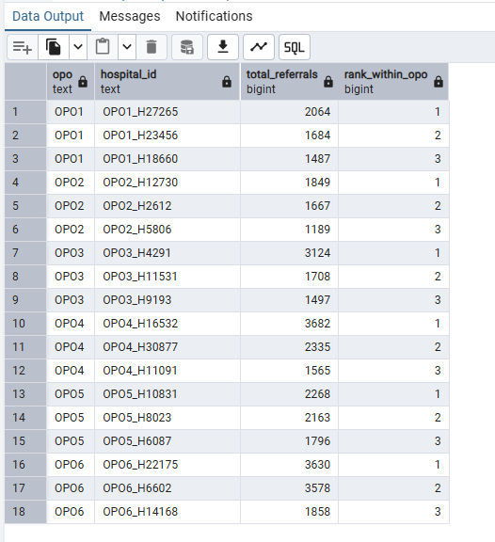
Insight
This analysis identifies the top 3 hospitals contributing the most donor referrals for each OPO. It
highlights which hospitals are driving the majority of referrals, allowing OPOs to focus resources,
improve coordination with high-performing hospitals, and provide support or training to
lower-performing hospitals. This helps optimize the organ donation process and ensures that
potential donors are captured efficiently.
2.For each cause_of_death_opo (death_info table), calculate the total number of patients,
the number who were authorized and procured (auth_status table), and the organ
procurement rate as a percentage.
Reason
This analysis examines how cause of death influences organ procurement success. By
comparing and ranking procurement rates by cause, we can identify patterns that help OPOs
improve donor management strategies and enhance organ donation outcomes.

Optimization Technique
- Use Indexes on Join and Filter Columns → speeds up matching rows across tables.
- Use CTEs (WITH clauses) for pre-aggregation → summarize data first to reduce rows before further calculations.
- Use Window Functions (ROW_NUMBER, RANK) → rank or order data efficiently without multiple queries.
- Avoid full table scans → indexes + pre-aggregation let PostgreSQL find and process only the needed rows.

Query
WITH cause_stats AS (
SELECT
d.cause_of_death_opo,
COUNT(p.patient_id) AS total_patients,
SUM(CASE WHEN a.authorized = TRUE THEN 1 ELSE 0 END) AS total_authorized,
SUM(CASE WHEN a.procured = TRUE THEN 1 ELSE 0 END) AS total_procured,
ROUND(
SUM(CASE WHEN a.procured = TRUE THEN 1 ELSE 0 END) * 100.0
/ COUNT(p.patient_id), 2
) AS procurement_rate
FROM patient p
JOIN death_info d
ON p.patient_id = d.patient_id
JOIN auth_status a
ON p.patient_id = a.patient_id
GROUP BY d.cause_of_death_opo
)
SELECT
cause_of_death_opo,
total_patients,
total_authorized,
total_procured,
procurement_rate,
RANK() OVER (ORDER BY procurement_rate DESC) AS procurement_rank
FROM cause_stats
ORDER BY procurement_rank;

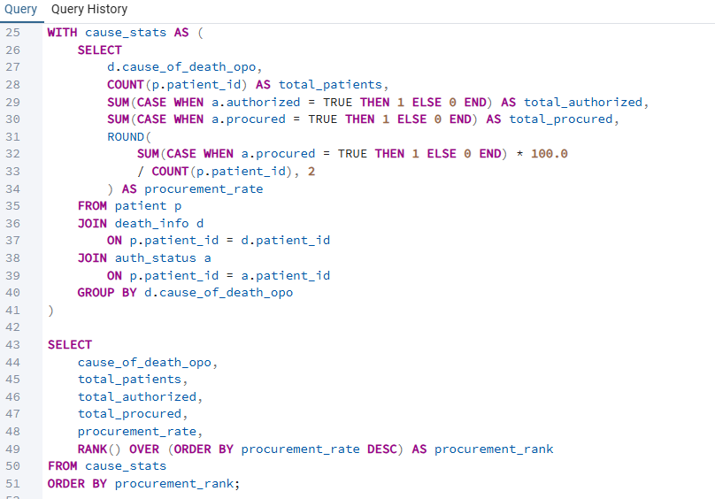

Output

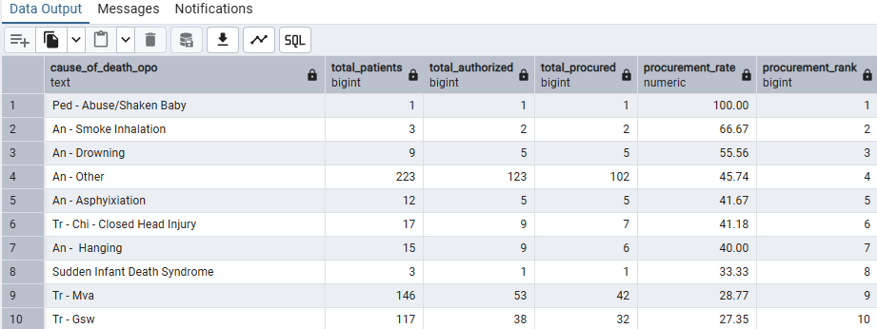

Insight
The analysis reveals which causes of death have higher or lower organ procurement rates,
helping OPOs identify medical scenarios with strong donor potential and areas where processes
can be improved to increase successful organ recovery.

3.For each OPO and referral_year, calculate the total number of referrals (from the patient
table) and compare it with the corresponding calc_deaths (from
calc_deaths_cleaned).Compute the difference between actual referrals and calculated
deaths, and rank OPOs within each year based on the size of this gap using a window
function.

Reason
This analysis identifies the performance gaps between actual referrals and the estimated
potential donor pool for each OPO and year. By calculating the difference and ranking OPOs,
we can quickly pinpoint which organizations are underperforming or overperforming relative
to expected donor availability. This provides actionable, data-driven insights that can help
improve referral processes, optimize resource allocation, and ultimately increase organ donation
rates.

Optimization Technique

Use CTEs (WITH clauses) for pre-aggregation → first summarize total referrals per OPO and year.
Use Indexes on Join Columns (opo, year) → speeds up joining referral_stats with calc_deaths_cleaned.
Use Window Functions (RANK) for ranking → rank gaps efficiently without multiple queries.
Reduce data scanned before ranking → grouping first and then joining/ranking improves performance on large datasets.
Query
WITH referral_stats AS (
SELECT
p.opo,
p.referral_year,
COUNT(p.patient_id) AS total_referrals
FROM patient p
GROUP BY p.opo, p.referral_year
),
gap_analysis AS (
SELECT
r.opo,
r.referral_year,
r.total_referrals,
c.calc_deaths,
(r.total_referrals - c.calc_deaths) AS referral_death_gap
FROM referral_stats r
JOIN calc_deaths_cleaned c
ON r.opo = c.opo
AND r.referral_year = c.year
)
SELECT
opo,
referral_year,
total_referrals,
calc_deaths,
referral_death_gap,
RANK() OVER (PARTITION BY referral_year ORDER BY referral_death_gap DESC) AS gap_rank_within_year
FROM gap_analysis
ORDER BY referral_year, gap_rank_within_year;

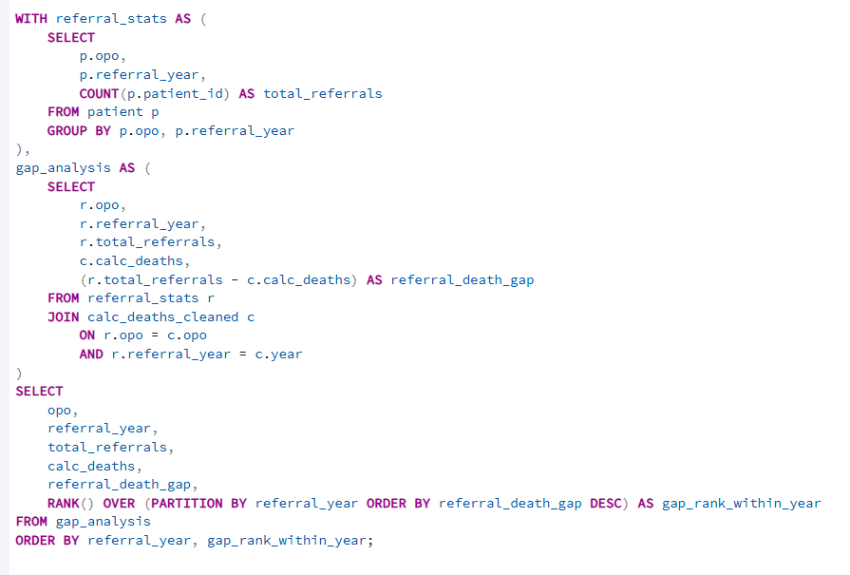

Output

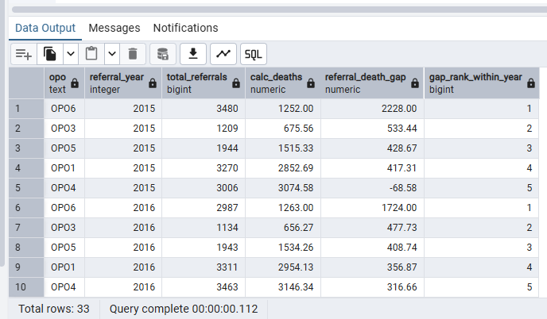
Insight
This analysis highlights which OPOs are referring fewer or more potential donors than expected
based on calculated deaths. It helps identify underperforming OPOs that may need process
improvements and overperforming OPOs that could serve as best-practice examples, providing
actionable insights to optimize organ donation efforts.

4.For each OPO (patient.opo), calculate the average time (in hours) from authorization to
procurement using auth_status.time_authorized and auth_status.time_procured.

Reason
I chose this analysis to measure the operational efficiency of OPOs by examining how quickly
they move from donor authorization to actual organ procurement. Time is critical in organ
donation, and delays can directly impact transplant success rates. By identifying which OPOs
have faster or slower turnaround times, we can uncover best practices, highlight bottlenecks,
and provide actionable insights to improve the overall organ donation process.

Optimization Technique

Use CTE (WITH clause) for pre-calculation → calculate hours to procure before aggregating.
- Use Indexes on Join Columns (patient_id) → speeds up joining patient and auth_status.
- Use Window Functions (RANK) for ranking → rank OPOs efficiently without extra queries.
- Filter early with IS NOT NULL → reduces rows processed in aggregation and ranking, improving performance.
Query
WITH authorization_procurement AS (
SELECT
p.opo,
EXTRACT(EPOCH FROM (a.time_procured - a.time_authorized)) / 3600 AS hours_to_procure
FROM patient p
JOIN auth_status a
ON p.patient_id = a.patient_id
WHERE a.time_authorized IS NOT NULL
AND a.time_procured IS NOT NULL
)
SELECT
opo,
ROUND(AVG(hours_to_procure), 2) AS avg_hours_authorization_to_procurement,
RANK() OVER (ORDER BY AVG(hours_to_procure)) AS rank_fastest_opo
FROM authorization_procurement
GROUP BY opo
ORDER BY rank_fastest_opo;
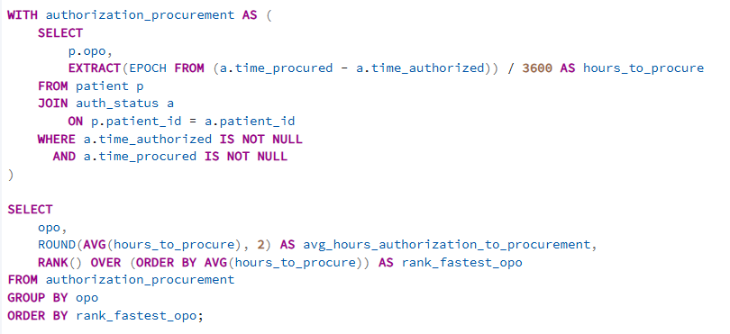

Output
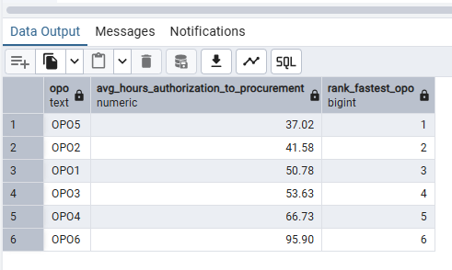

Insight
This analysis reveals which OPOs are most efficient in converting donor authorization into actual
procurement. Faster turnaround times indicate strong coordination and streamlined processes,
while longer delays may signal operational bottlenecks that could impact organ viability and
transplant success.

5.For each OPO, calculate the total number of referrals per referral_year from the patient
table and compute the cumulative number of referrals over time.

Reason
I chose this analysis to understand long-term referral trends and growth patterns for each OPO.
By calculating cumulative referrals over time, we can identify whether an OPO is improving,
stagnating, or declining in donor referrals. This helps highlight performance momentum,
measure the impact of process improvements, and provide strategic insights for increasing
organ donation rates.

Optimization Technique
- Use CTE (WITH clause) for pre-aggregation → summarize yearly referrals per OPO before calculating cumulative totals.
- Use Window Functions (SUM OVER) → calculate cumulative referrals efficiently without multiple queries.
- Use Indexes on Join/Group Columns (opo, referral_year) → speeds up grouping and ordering.
- Reduce rows early → pre-aggregation in the CTE makes cumulative calculation faster on large datasets.
Query
WITH yearly_referrals AS (
SELECT
opo,
referral_year,
COUNT(patient_id) AS total_referrals
FROM patient
GROUP BY opo, referral_year
)
SELECT
opo,
referral_year,
total_referrals,
SUM(total_referrals) OVER (
PARTITION BY opo
ORDER BY referral_year
ROWS BETWEEN UNBOUNDED PRECEDING AND CURRENT ROW
) AS cumulative_referrals
FROM yearly_referrals
ORDER BY opo, referral_year;

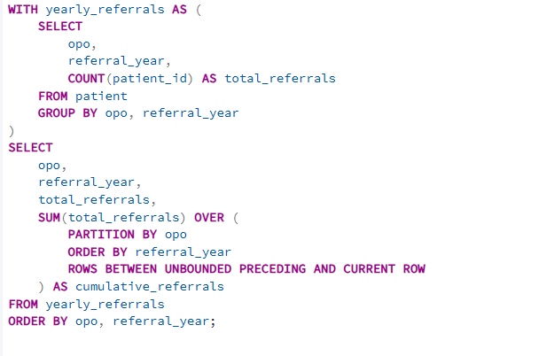

Output
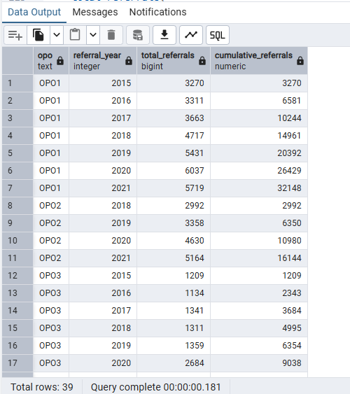

Insight
This analysis reveals whether each OPO’s referral volume is consistently growing over time or
showing signs of decline. A steady upward cumulative trend indicates sustained improvement,
while flat or slow growth may signal the need for stronger outreach or operational
enhancements.

6.For each circumstances_of_death (death_info table), calculate the total number of
donors, the number of successfully transplanted cases (auth_status.transplanted), and
the transplant success rate as a percentage.

Reason
I chose this analysis to understand how different circumstances of death affect transplant
success and overall organ procurement outcomes. By calculating transplant rates and adding a
cumulative metric, we can identify which circumstances contribute most to successful
transplants and highlight areas where processes may need improvement. This provides
actionable, data-driven insights that are highly valuable for optimizing organ donation strategies

Optimization Technique

Use CTE (WITH clause) for pre-aggregation → summarize total donors and transplanted

counts first.

Use Window Functions (SUM OVER) → calculate cumulative transplanted efficiently without extra queries.

Use Indexes on Join Columns (patient_id) → speeds up joining patient, death_info, and auth_status.

Reduce data early → grouping in the CTE reduces rows processed in the final calculation, improving performance.

Query

WITH donor_analysis AS (
SELECT
d.circumstances_of_death,
COUNT(*) AS total_donors,
SUM(CASE WHEN a.transplanted = TRUE THEN 1 ELSE 0 END) AS transplanted_count
FROM patient p
JOIN death_info d
ON p.patient_id = d.patient_id
JOIN auth_status a
ON p.patient_id = a.patient_id
GROUP BY d.circumstances_of_death
)
SELECT
circumstances_of_death,
total_donors,
transplanted_count,
ROUND(
transplanted_count * 100.0 / NULLIF(total_donors, 0),
2
) AS transplant_rate_percent,
SUM(transplanted_count) OVER (ORDER BY ROUND(transplanted_count * 100.0 / NULLIF(total_donors, 0), 2) DESC)
AS cumulative_transplanted
FROM donor_analysis
ORDER BY transplant_rate_percent DESC;

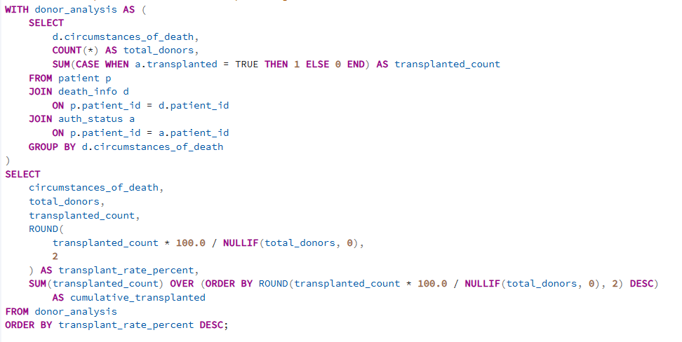

Output

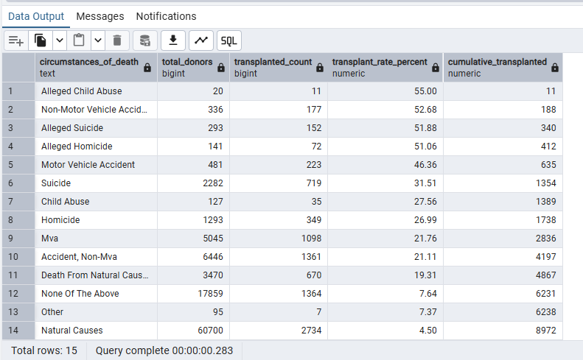

Insight
This analysis shows which circumstances of death are associated with higher transplant success
and their cumulative impact. It helps identify key scenarios contributing most to successful
transplants, enabling OPOs to focus efforts and improve organ donation outcomes.

7. Find the top 3 hospitals per year by transplant count

Optimization Techniques
- Filtering data
We filter only transplanted = true records before counting.
- Use indexes on join columns
Indexes on patient_id and joins the patient and auth_status tables faster.
- Creating an index only for rows where transplanted = true.
- Grouping procured_year and hospital_id helps and sort data more efficiently.
- We first calculate the count of transplanted patients per hospital per year.
DENSE_RANK() is applied after aggregation

Query
WITH hospital_year AS (
SELECT
p.procured_year,
p.hospital_id,
COUNT(DISTINCT p.patient_id) AS transplanted_patients
FROM patient p
JOIN auth_status a ON a.patient_id = p.patient_id
WHERE a.transplanted = true
AND p.procured_year IS NOT NULL
AND p.hospital_id IS NOT NULL
GROUP BY p.procured_year, p.hospital_id
),
ranked AS (
SELECT
*,
DENSE_RANK() OVER (PARTITION BY procured_year ORDER BY transplanted_patients DESC) AS hospital_rank
FROM hospital_year
)
SELECT *
FROM ranked
WHERE hospital_rank <= 3
ORDER BY procured_year, hospital_rank, transplanted_patients DESC;

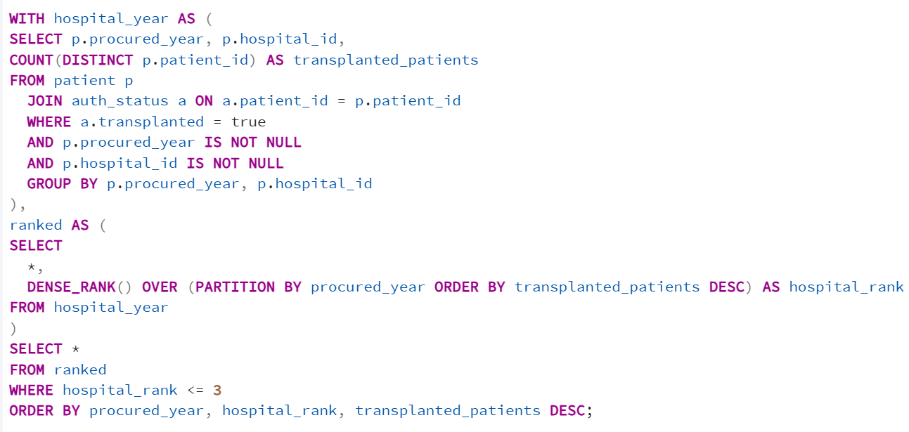

Output
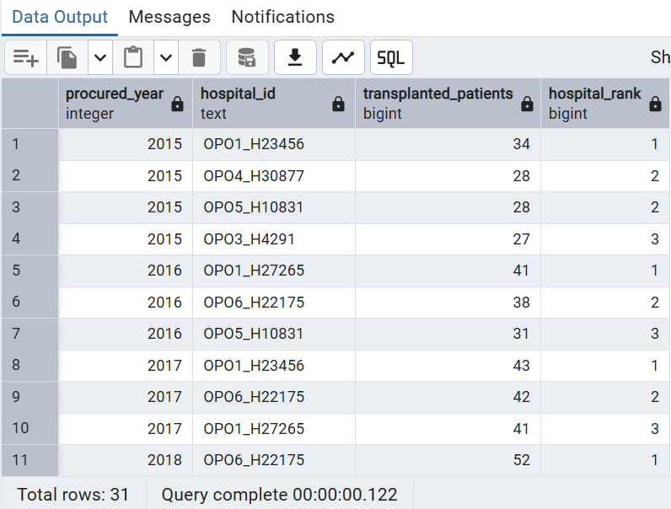

Insight
- This query shows which hospitals perform the most transplants each year.
- It helps us identify the top 3 hospitals for every year.

8.Show month-wise referral counts and month-over-month count change.

Optimization Techniques
- The first CTE (m) turns raw data into a small monthly summary.
- Then LAG() runs on that smaller result, so it’s faster than running on all rows.
- Add an index on auth_status(time_referred) so that it can filter dates faster.
- COUNT(DISTINCT patient_id)
Query
WITH month_wise AS (
SELECT
date_trunc('month', a.time_referred) AS month,
COUNT(DISTINCT a.patient_id) AS referral_count
FROM auth_status a
WHERE a.time_referred IS NOT NULL
GROUP BY 1
)

SELECT
month,referral_count,
LAG(referral_count) OVER (ORDER BY month) AS prev_month_referrals,
(referral_count - LAG(referral_count) OVER (ORDER BY month)) AS month_over_month_count_change
FROM month_wise
ORDER BY month;

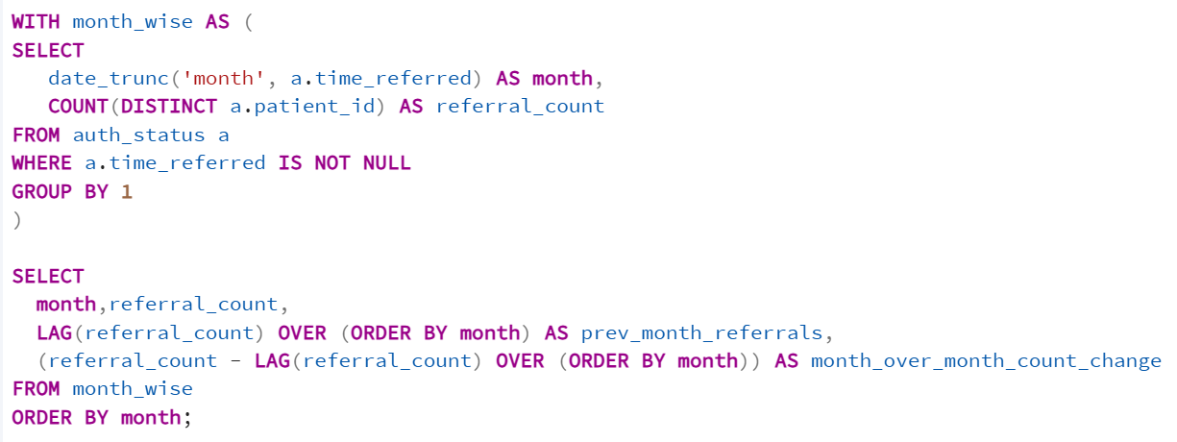

Output
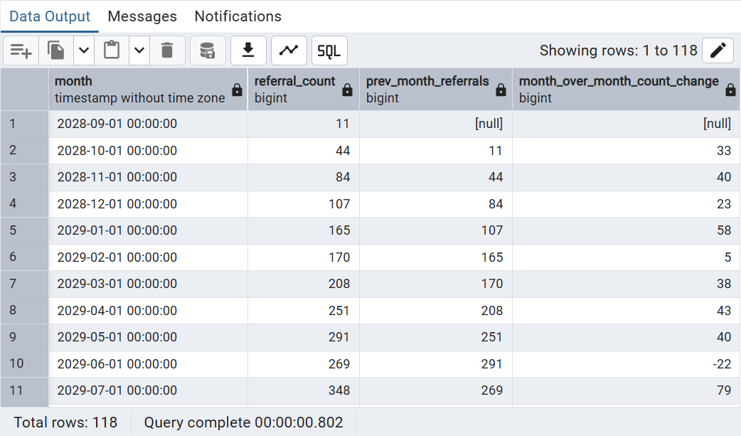
Insight
- This shows how many referrals happened each month.
- It compares each month with the previous month.
- Month_over_month_count_change tells us how many more or fewer referrals you got compared to last month.

9. Find year-wise brain-death cases and a running total across years.
Optimization Techniques
- Filter early - WHERE d.brain_death = true AND p.procured_year IS NOT NULL limits data before grouping, so aggregation runs on fewer rows.
- Aggregate at the right grain first
The CTE totals do the year-wise counts. The outer query then does only the running total on a small result set.
- Use COUNT(DISTINCT ) to avoid double-counting
- Window function is used for running totals
SUM(brain_death_count) OVER (ORDER BY procured_year)
- Indexes to support join + filtering - brain_death_patient_info,patient_procured_year.

Query
WITH totals AS (
SELECT
p.procured_year,
COUNT(DISTINCT d.patient_id) AS brain_death_count
FROM death_info d
JOIN patient p ON p.patient_id = d.patient_id
WHERE d.brain_death = true
AND p.procured_year IS NOT NULL
GROUP BY p.procured_year
)
SELECT
procured_year,
brain_death_count,
SUM(brain_death_count) OVER (ORDER BY procured_year) AS running_total
FROM totals
ORDER BY procured_year;
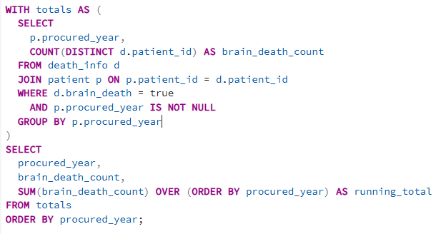
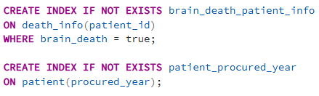
Output
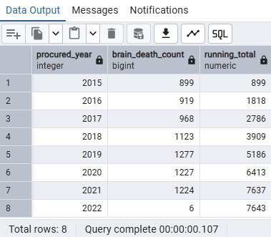
Insight
- The first output (procured_year, brain_death_count) shows whether brain-death cases are increasing, decreasing, or stable over time.
- The running total shows the overall accumulation of brain-death cases

10. Determine the time taken from referral to procurement in hours and categorize patients into predefined time intervals.

Optimization Techniques
- a.time_procured - a.time_referred, gives a time interval
- EXTRACT(EPOCH FROM interval) , converts that interval into seconds
- Handle NULLs early to avoid wrong calculations, WHEN a.time_procured IS NULL OR a.time_referred IS NULL THEN 'Time Unknown'
- Sorting by year for easier reporting , ORDER BY p.procured_year

Query
SELECT
a.patient_id,
p.procured_year,
ROUND(EXTRACT(EPOCH FROM (a.time_procured - a.time_referred)) / 3600.0, 2) AS referral_to_procurement_hours,
CASE
WHEN a.time_procured IS NULL OR a.time_referred IS NULL THEN 'Time Unknown'
WHEN a.time_procured - a.time_referred <= INTERVAL '6 hours' THEN '0–6 hrs'
WHEN a.time_procured - a.time_referred <= INTERVAL '24 hours' THEN '6–24 hrs'
WHEN a.time_procured - a.time_referred <= INTERVAL '72 hours' THEN '1–3 days'
ELSE '3+ days'
END AS procurement_time_range
FROM auth_status a
JOIN patient p ON p.patient_id = a.patient_id
ORDER BY p.procured_year;
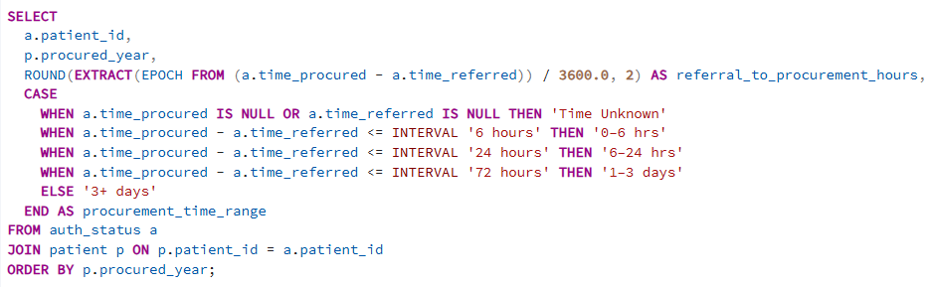

Output
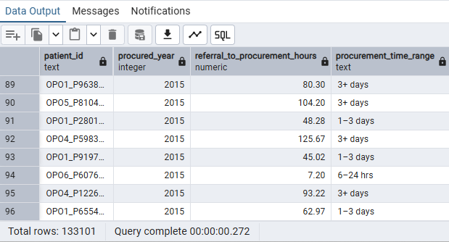
Insight
- It calculates how many hours it took for each patient from referral time to procurement time.
- It assigns each patient into a time range(0–6 hrs, 6–24 hrs, 1–3 days, 3+ days, or Time Unknown).

11.Find the average time (in hours) taken from referral to authorization for patients.

Optimization Techniques
- We calculate the time difference only once per row.
- Rows with missing timestamps are removed to avoid unnecessary calculations.
- Using a single aggregation (AVG) to find the average.

Query
SELECT
ROUND(
AVG(EXTRACT(EPOCH FROM (a.time_authorized - a.time_referred)) / 3600.0),2)
AS avg_hours_referral_to_auth
FROM auth_status a
WHERE a.time_referred IS NOT NULL
AND a.time_authorized IS NOT NULL;
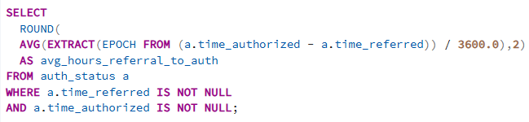
Output
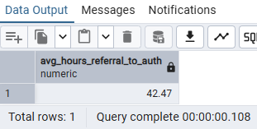

Insight
- Shows how long, on average, authorization takes after referral.
- Helps identify delays in the authorization process.
- Useful for tracking process efficiency and improvement over time.

12. For each referral year, rank hospitals based on the number of procured patients, with the highest count ranked first.

Optimization Techniques
- Used CTE, The CTE pre-aggregates year-wise and hospital-wise procurement counts, reducing the dataset size before applying window functions.
- Filter early (reduce rows before grouping)
WHERE a.procured = true AND p.referral_year IS NOT NULL reduces the dataset before GROUP BY, making aggregation faster.
- Used the right indexes ,Joins - auth_status(patient_id), patient(patient_id)

Query
WITH hospital AS (
SELECT p.referral_year, p.hospital_id, COUNT(*) AS procured_count
FROM patient p
JOIN auth_status a ON a.patient_id = p.patient_id
WHERE a.procured = true AND p.referral_year IS NOT NULL
GROUP BY p.referral_year, p.hospital_id)
SELECT *,
RANK() OVER (PARTITION BY referral_year ORDER BY procured_count DESC) AS hospital_rank
FROM hospital
ORDER BY referral_year, hospital_rank;

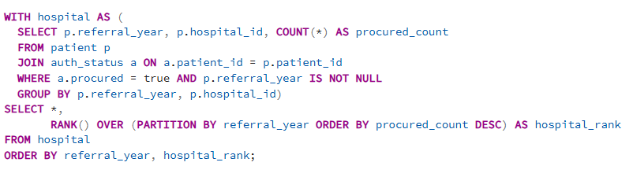
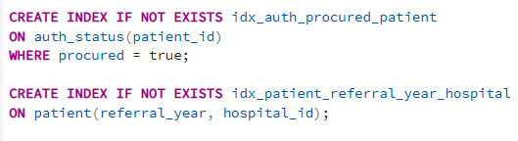

Output
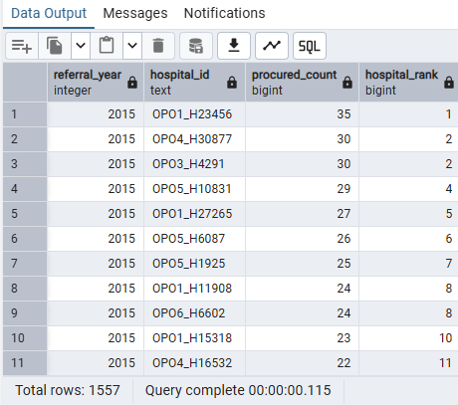

Insight

- It calculates the number of procured cases per hospital for each referral year.
- It ranks hospitals within each year based on how many procurements they completed.
- It helps identify top-performing hospitals year-by-year.

13.Year-over-year referral growth

Reason:
To find how the referral growth got increased or decreased every year.

Optimized Techniques:
1.Used GROUP BY with COUNT(*), which is the most efficient way to aggregate totals.
2.Used a window function (LAG), which calculates the previous year’s value in the same query without self-joins or subqueries, making it faster and cleaner.
3.Performed the growth calculation directly inside SQL, avoiding extra processing steps.
4.Used NULLIF to prevent division by zero, which keeps the logic efficient without extra conditions.
5.Grouped only by referral_year, keeping the aggregation simple and lightweight.

Query
SELECT
p.referral_year,
COUNT(*) AS total_referrals,
ROUND(
100.0 *
(COUNT(*) - LAG(COUNT(*)) OVER (ORDER BY p.referral_year)) /
NULLIF(LAG(COUNT(*)) OVER (ORDER BY p.referral_year), 0),
2) AS growth_percentage
FROM patient p
GROUP BY p.referral_year
ORDER BY p.referral_year;

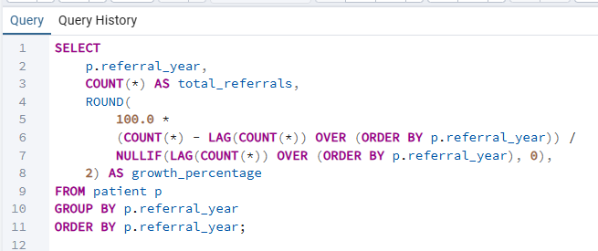

Output
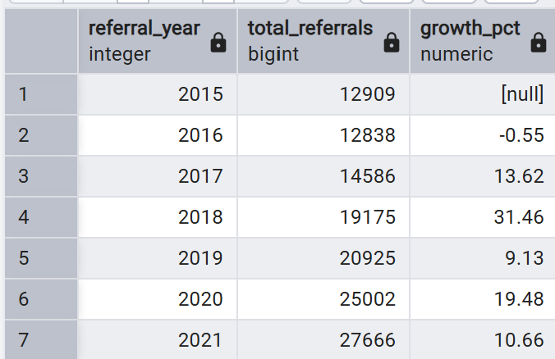
Insights
This query provides a yearly summary of patient referrals and their growth rates, giving insights
into trends over time and helping monitor how referrals are changing each year.

14.Longest time to procurement (dense rank)
Reason:
To find the most 5 longest time taken for procurement.

Optimization Techniques
1.Filtered rows early using WHERE procured = true, which reduces the number of rows before ranking and improves performance.
2.Used a window function (DENSE_RANK) instead of subqueries or self-joins, which is faster and more efficient for ranking.
3.Calculated the delay directly in the query, avoiding extra computations later.
4.Selected the top 5 using ranking logic, which avoids sorting the entire dataset multiple times.
Query:
SELECT *
FROM (
SELECT
patient_id,
time_procured - time_referred AS delay,
DENSE_RANK() OVER (ORDER BY time_procured - time_referred DESC) rnk
FROM auth_status
WHERE procured = true
) s
WHERE rnk <= 5;

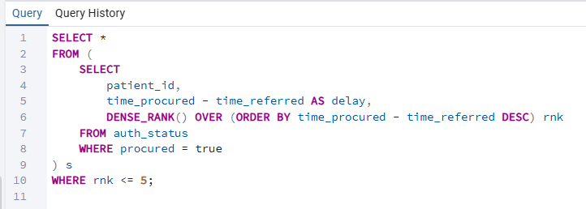

Output

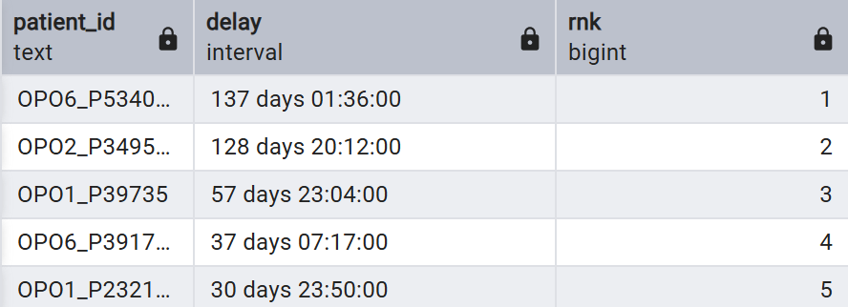

Insights:
This query identifies the 5 patients with the longest organ procurement delays, giving
insights into process efficiency and potential areas for improvement.

15.Detect sudden spike in procurement (LEAD difference)
Reason:
To find every year how the procurement count has been increased or decreased every year for all the OPOS.
Optimization Techniques
1.Filtered rows early using WHERE a.procured, which reduces the dataset before grouping and improves performance.
2.Used GROUP BY with COUNT(*), which is the most efficient way to calculate totals.
3.Used a window function (LEAD), which avoids slower self-joins or subqueries for next-year comparison.
4.Calculated the difference directly in SQL, avoiding extra processing steps.
5.Used USING(patient_id) for a cleaner and slightly more efficient join condition.
Query
SELECT *,
LEAD(procured_cnt) OVER (PARTITION BY opo ORDER BY referral_year) - procured_cnt AS next_year_jump
FROM (
SELECT
p.opo,
p.referral_year,
COUNT(*) AS procured_cnt
FROM patient p
JOIN auth_status a USING(patient_id)
WHERE a.procured
GROUP BY p.opo, p.referral_year
) s;

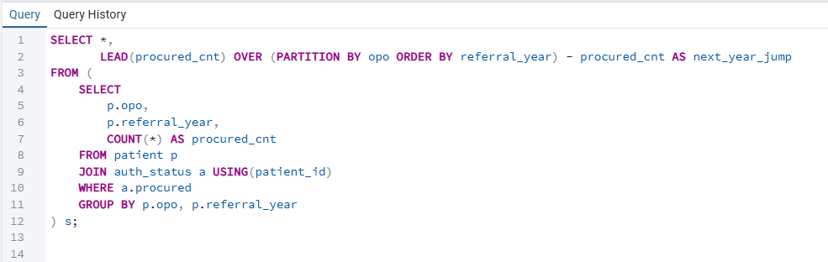

Output
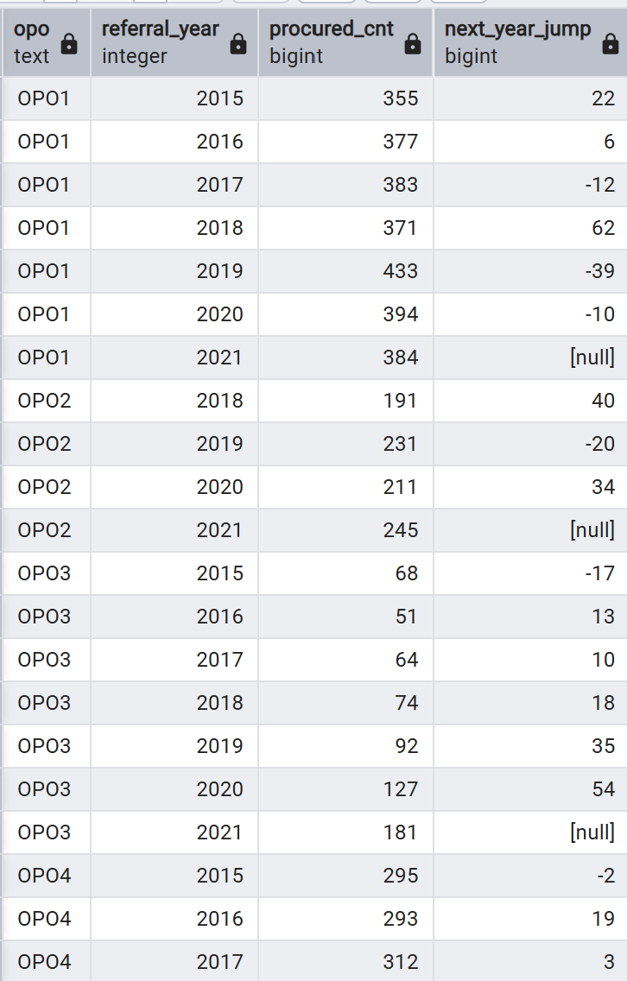
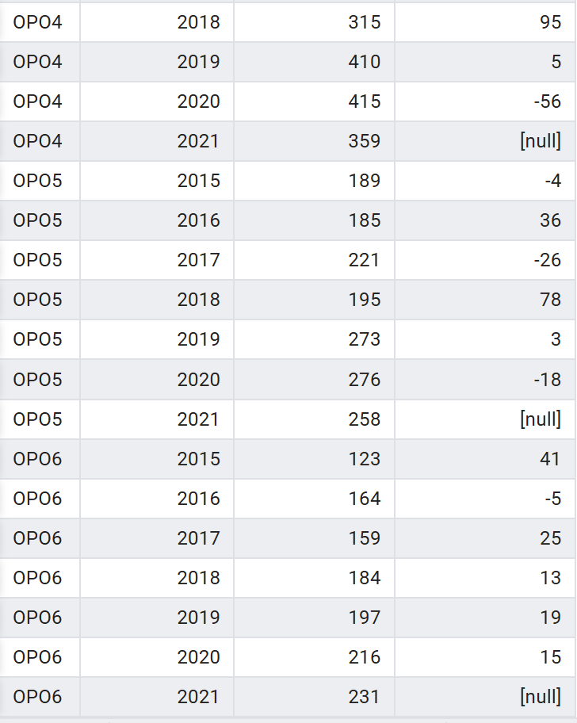

Insights:
This query gives yearly procured organ counts per OPO and highlights changes in procurement numbers year-over-year, showing trends and performance shifts for each organization.

16.Min,Median,Max patient age per OPO (percentile_cont).

Reason:
To find minimum,maximum and medium patient age of each OPO.

Optimization Techniques:
1.Filtered rows early with WHERE age IS NOT NULL, which reduces the data processed by aggregates.
2.Calculated MIN, MAX, and median in a single grouped query, avoiding multiple scans or separate queries.
3.Used aggregate functions (MIN, MAX, percentile_cont) which are efficient and optimized in PostgreSQL.Used set-ba
4.Grouped only by opo, keeping aggregation simple and lightweight.

Query
SELECT
opo,
'minimum age: ' || MIN(age)
|| ', median age: ' ||
percentile_cont(0.5) WITHIN GROUP (ORDER BY age)
|| ', max age(if age>89 consider as 100): ' || MAX(age) AS age_summary
FROM patient
WHERE age IS NOT NULL
GROUP BY opo
ORDER BY opo;

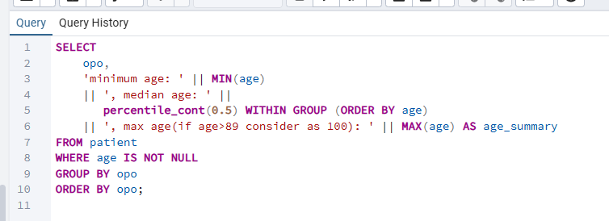

Output:

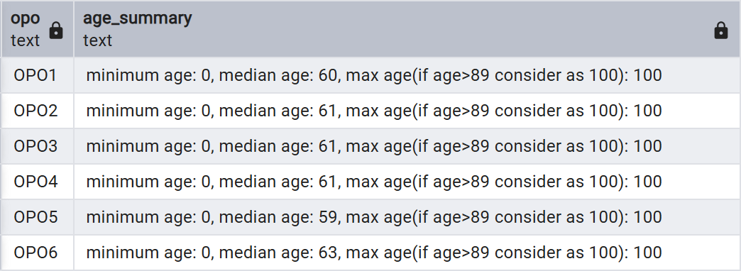

Insights:
This query provides a summary of patient ages per OPO, showing the minimum, median, and maximum ages, which helps understand age distribution and trends among patients in each OPO.

17. Generate hospital performance score (composite metric)
Reason:
To find the performance score based on the authorized and procured count for all the hospitals.

Optimization Techniques:
1.Used COUNT(*) FILTER (WHERE …), which is an efficient and clean way to do conditional counting instead of multiple SUM(CASE WHEN …) expressions.
2.Filtered and aggregated directly in the grouped query, avoiding extra subqueries or multiple scans.
3.Used JOIN … USING(patient_id), which is cleaner and slightly more efficient for joining tables.
4.Grouped only by hospital_id, keeping the aggregation minimal and fast.
5.Calculated the performance_score directly in SQL, combining the metrics in a single pass.

Query
SELECT
p.hospital_id,
COUNT(*) FILTER (WHERE a.authorized) AS authorized,
COUNT(*) FILTER (WHERE a.procured) AS procured,
ROUND(
0.6 * COUNT(*) FILTER (WHERE a.procured)
+ 0.4 * COUNT(*) FILTER (WHERE a.authorized)
,2) AS performance_score
FROM patient p
JOIN auth_status a USING(patient_id)
GROUP BY p.hospital_id
ORDER BY performance_score DESC;

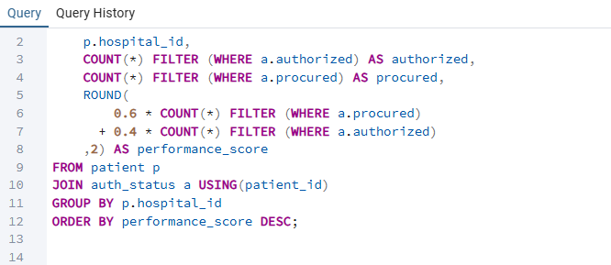

Output
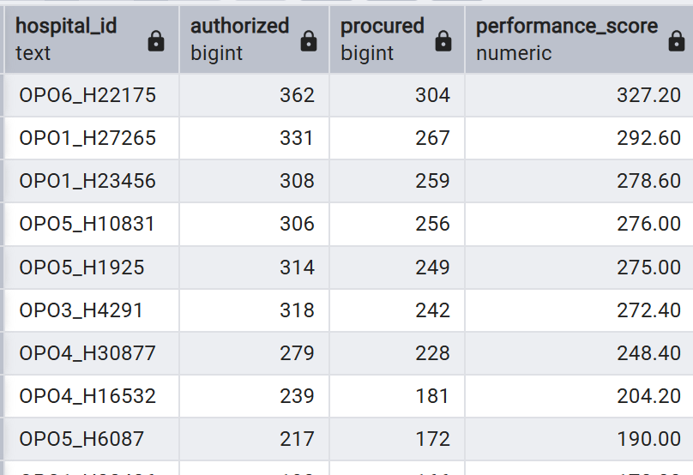
Insights:
This query provides hospital-level performance metrics, showing which hospitals are most effective at getting patient authorization and actually procuring organs, along with a combined weighted performance score.

18.Average time between referral and procurement per hospital.
Reason:
To find average time between referral and procurement based on hospital.

Optimized Techniques:
1.Filtered rows early with WHERE a.procured, which reduces the dataset before aggregation.
2.Calculated the average directly in SQL using AVG(EXTRACT(EPOCH …)/3600), avoiding extra processing outside the query.
3.Used JOIN … USING(patient_id), which is clean and efficient for joining the two tables.
4.Grouped only by hospital_id, keeping the aggregation minimal and fast.

Query:
SELECT
Hospital_id,
ROUND(AVG(EXTRACT(EPOCH FROM (time_procured - time_referred))/3600),2) AS avg_hours_to_procure
FROM patient p
JOIN auth_status a USING(patient_id)
WHERE a.procured
GROUP BY hospital_id;

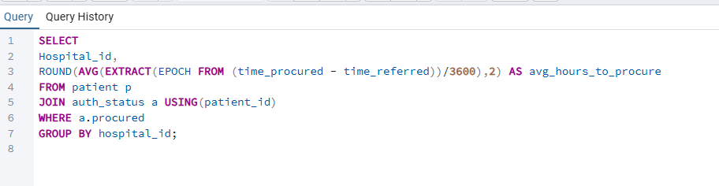

Output:
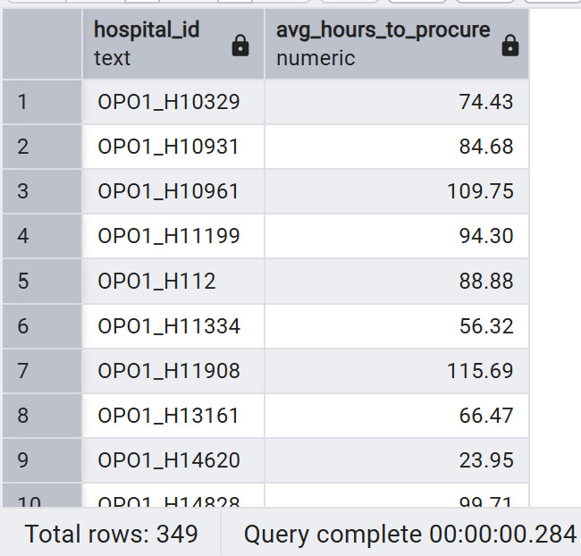

Insights:
This query provides the average time from referral to organ procurement per hospital, giving insights into hospital efficiency and speed of the procurement process.

19.Ranking opo's per year along with the avg age of the patient for brain death patient ?

Reason :
compare and benchmark OPO performance year-over-year while also understanding the demographic profile (average age) of brain death patients, helping identify trends, performance differences, and potential age-related impacts on donation outcomes.

Optimization :
- Remove the unnecessary subquery and apply the RANK() window function directly after aggregation to reduce extra processing.
- Use COUNT(*) instead of COUNT(d.brain_death) for faster row counting.
- Apply early filtering with WHERE d.brain_death IS TRUE to reduce rows before join and grouping.

Query :
select opo,referral_year,total_brain_death_case,rank()over(partition by referral_year order by total_brain_death_case desc )as rank_opo ,avg_age from
(select p.opo,p.referral_year,count(d.brain_death) as total_brain_death_case, round( avg(p.age),1) as avg_age
from death_info d join patient p on p.patient_id = d.patient_id
where d.brain_death = true group by p.opo,p.referral_year) order by referral_year, rank_opo;

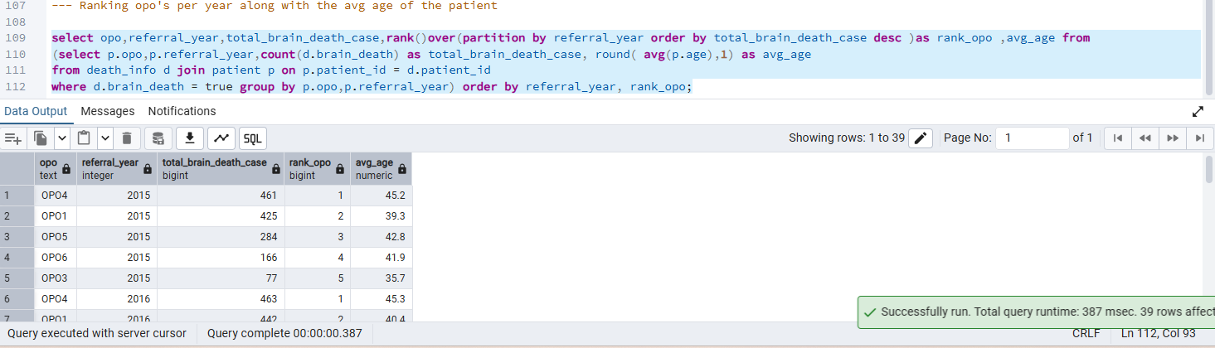

Insight: The above syntax shows that total brain death cases per year with raking and the average age of the patient, enabling year-over-year performance comparison, volume benchmarking across opos and analysis of whether demographic factor(age) influence brain death trends .

20. How has the number of brain death cases changed year-over-year for each Organ Procurement Organization (OPO), and which OPOs are seeing an increase, decrease, or no change in cases compared to the previous year?
Reason:
To analyze year-over-year in brain death cases by identifying whether the no.of cases increased or decreased compared to the previous year, helping detect the growth patterns.

Optimization :
- Use FILTER in aggregates to avoid extra filtering overhead.
- Flatten nested subqueries into a single CTE.
- Add indexes on join and group columns.
- Avoid repeating LAG() calculation by computing it once if needed.
Query :
select opo,referral_year,total_brain_death_case ,pervious_year_cases, total_brain_death_case-pervious_year_cases as diff_year_cases,
case
when total_brain_death_case-pervious_year_cases >0 then 'increased'
when total_brain_death_case-pervious_year_cases<0 then 'decreased'
else 'no change ' end as trend
from (select opo,referral_year, total_brain_death_case ,LAG(total_brain_death_case) over(partition by opo order by referral_year)as pervious_year_cases
from
(select p.opo,p.referral_year,count(d.brain_death) as total_brain_death_case
from
death_info d join patient p on p.patient_id = d.patient_id
where d.brain_death = true group by p.opo,p.referral_year ))order by referral_year;

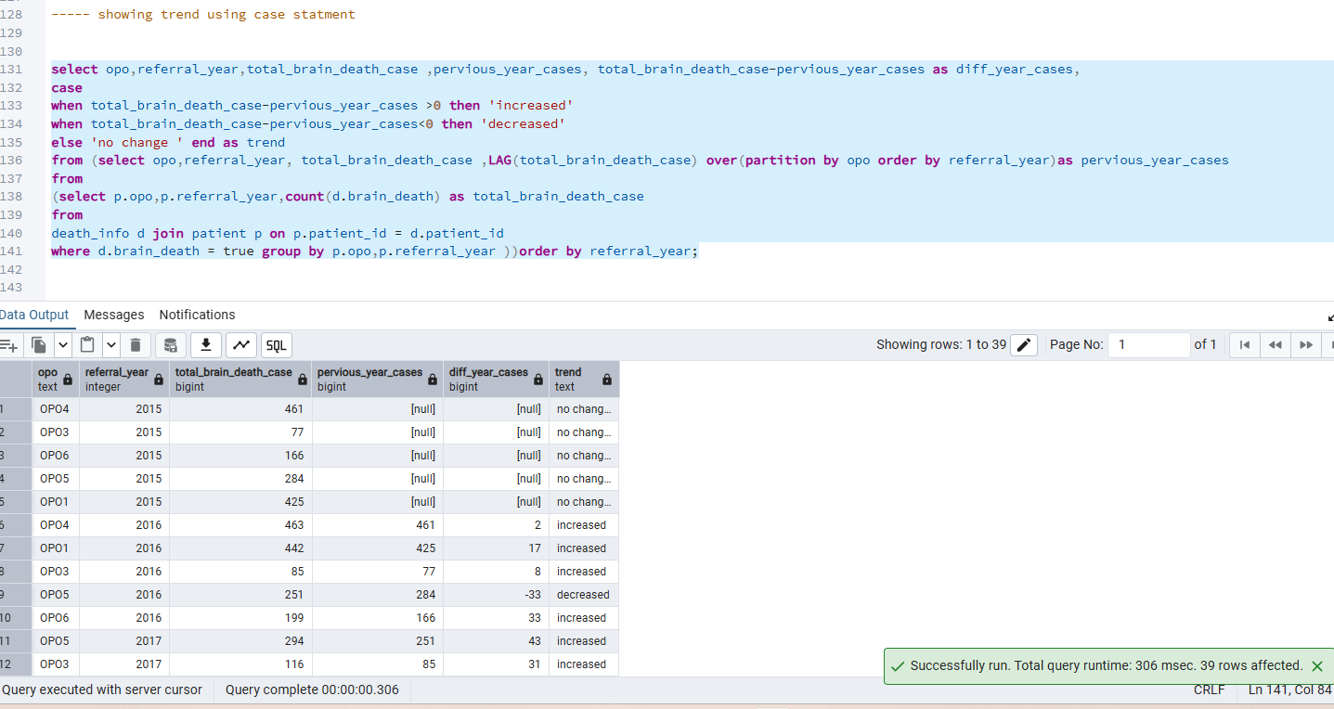

Insight : The query calculates total brain death cases per opo per year
The LAG() window dunction to get the total cases from the previous year for each opo.
It also computes the difference in cases year -over year with categorizes as Increased, decreased and no change.

21.How has the average age of patients with brain death changed year-over-year for each Organ Procurement Organization (OPO), and is the trend increasing, decreasing, or remaining the same?
Reason
Understanding the year- over – year changes in the average age of brain death patient can help and to detect trends that might influence organ donation program .

Optimization :
- Use FILTER in aggregates to avoid extra filtering overhead.
- Flatten nested subqueries into a single CTE.
- Add indexes on join and group columns.
- Avoid repeating LAG() calculation by computing it once if needed.

Query
select opo,referral_year,avg_age,pervious_age,
avg_age-pervious_age >0 then 'increased'
avg_age-pervious_age<0 then 'decreased'
'no change ' end as trend
(select opo,referral_year, avg_age ,LAG(avg_age) over(partition by opo order by referral_year)as pervious_age
p.opo,p.referral_year,round( avg(p.age),1) as avg_age
d join patient p on p.patient_id = d.patient_id
d.brain_death = true group by p.opo,p.referral_year ))order by referral_year;
Output
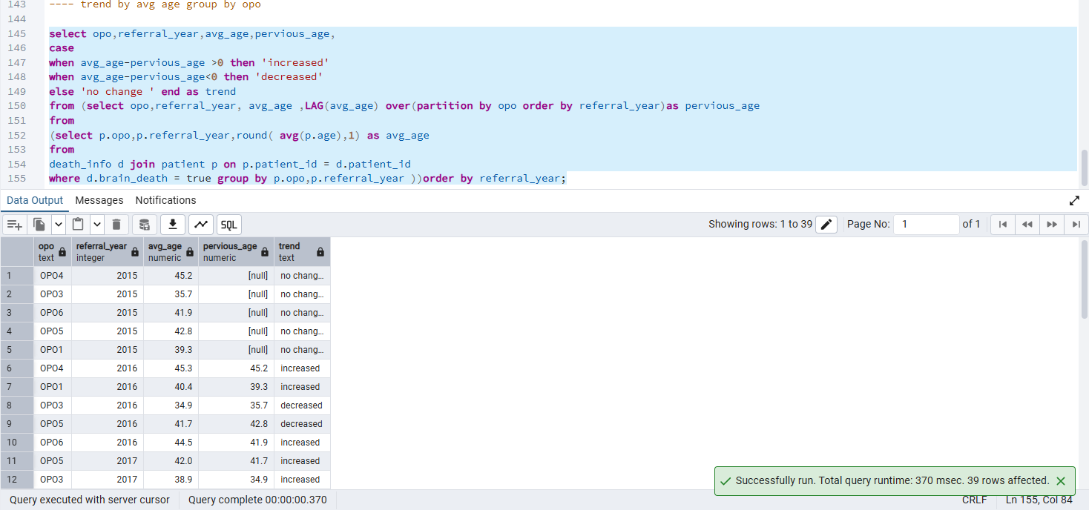
Insight: The inner most query calculates the average age of brain death patients per opo per year using avg(p.age) and rounds it to one decimal place.
The middle query uses the lag window function to capture the average age from the pervious yeat for each opo.
The outer query calculates the trend by comparing avg_ age with pervious_age.

22.What is the proportion of brain death cases contributed by each Organ Procurement Organization (OPO) within a given year, and how does each OPO compare to the yearly total?

Reason: understand each OPO’s contribution, To identify OPOs with disproportionately high or low case counts.

Optimization:
- Use CTEs for clarity and optimization.
- Add indexes on join and filter columns.
- Use FILTER for conditional counting to reduce row scanning.

Query:
with yearly_cases as (
select
p.opo,
p.referral_year,
count(*) as total_brain_death_case

from death_info d
join patient p on p.patient_id = d.patient_id
where d.brain_death = true group by p.opo, p.referral_year
)
select
opo,
referral_year,
total_brain_death_case,

sum(total_brain_death_case) over (
partition by referral_year
) as yearly_total,
ROUND(
total_brain_death_case * 100.0 /
sum(total_brain_death_case) over(partition by referral_year),
2) as percent_of_year
from yearly_cases
order by referral_year, opo;
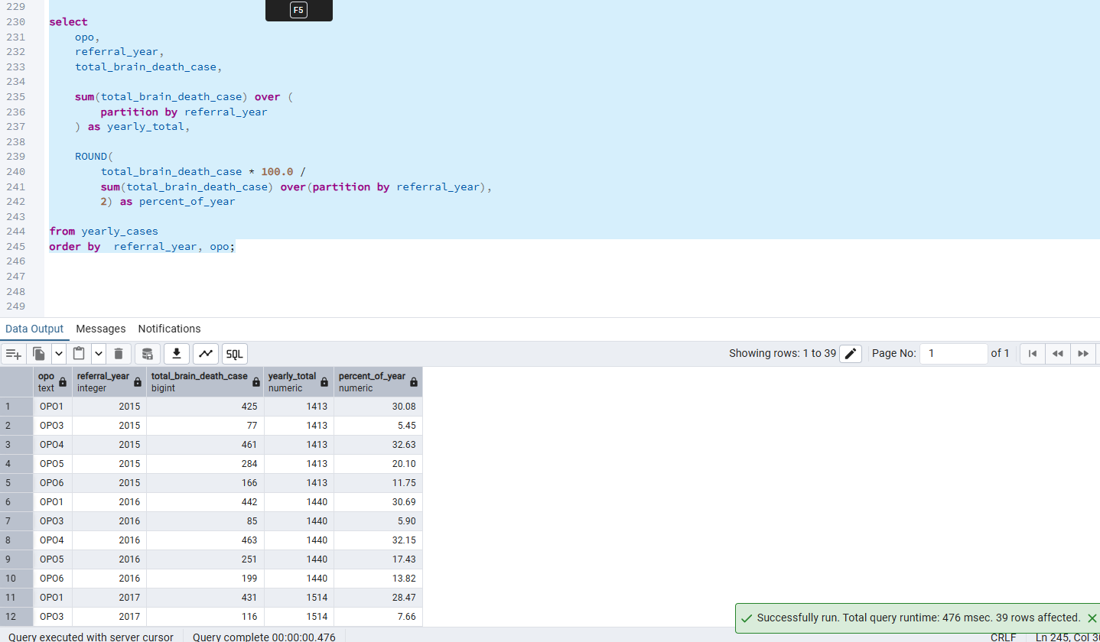
Insight: The CTE yearly cases calculates the total brain death cases per OPO per year. The query uses window function sum() over ( partition by referral_year) to calculate the total brain death cases across all opos for each year. Round(,2) ensures the percentage is displayed with two decimal places.

23.What is the projected change in brain death cases for each Organ Procurement Organization (OPO) by comparing the current year’s total with the next year’s total?
Optimization :
- Window function (LEAD) for next-year comparison instead of self-join.
- Flatten nested queries using CTEs for readability and optimization.
- Compute window functions once to avoid duplication.
- Indexes on join and filter columns for faster access.
Query :
select opo,referral_year,total_brain_death_case ,next_year_cases, next_year_cases - total_brain_death_case as diff_year_cases
from (select opo,referral_year, total_brain_death_case ,Lead(total_brain_death_case) over(partition by opo order by referral_year)as next_year_cases
from
(select p.opo,p.referral_year,count(d.brain_death) as total_brain_death_case
from
death_info d join patient p on p.patient_id = d.patient_id
where d.brain_death = true group by p.opo,p.referral_year ))order by referral_year,opo;

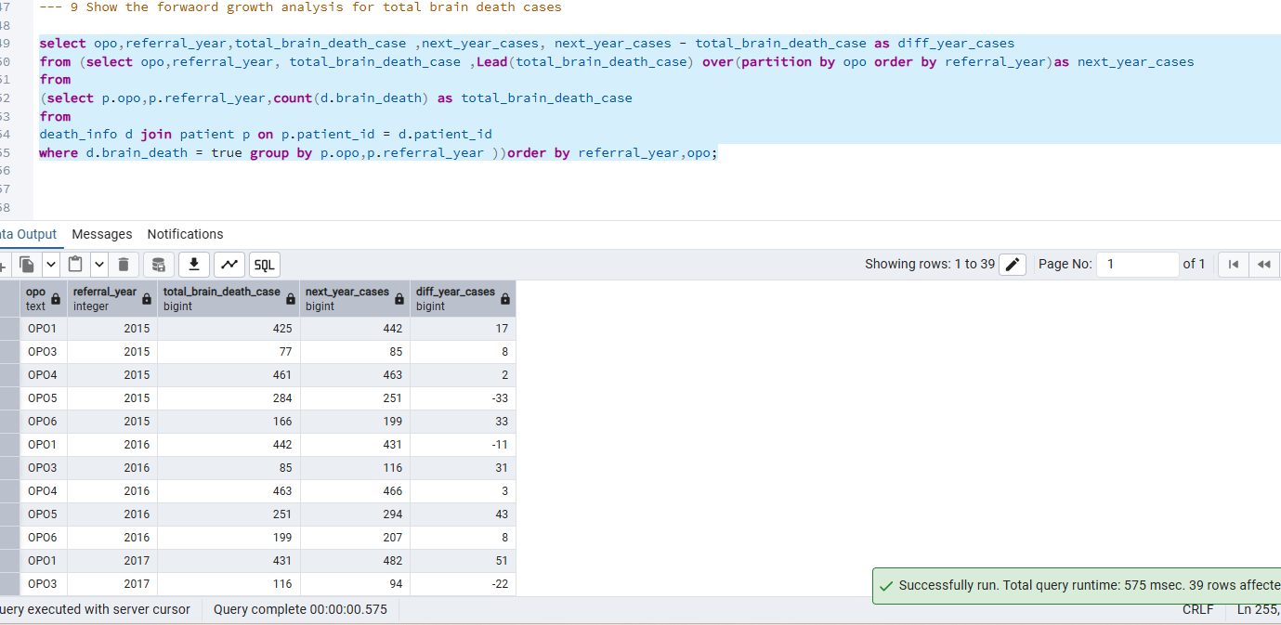

Insight
It gives the details number for the pervious year and next year difference and growth case for total brain dead cases.

24. Show the difference as after how many days it took to procured the organ after death
Reason: Understanding this delay is important to assess efficiency, compliance with medical protocols, and optimize organ/tissue utilization.
Optimization technic :
- Early filtering using WHERE before join.
- Proper indexing on join and filter columns
- Selecting only required columns.
- Aggregate after filtering for efficiency.
Query:
select d.brain_death,d.time_brain_death ,a.patient_id,a.time_procured,time_procured-time_brain_death as days_procured
from
death_info d join auth_status a on a.
patient_id = d.patient_id where brain_death = true ;

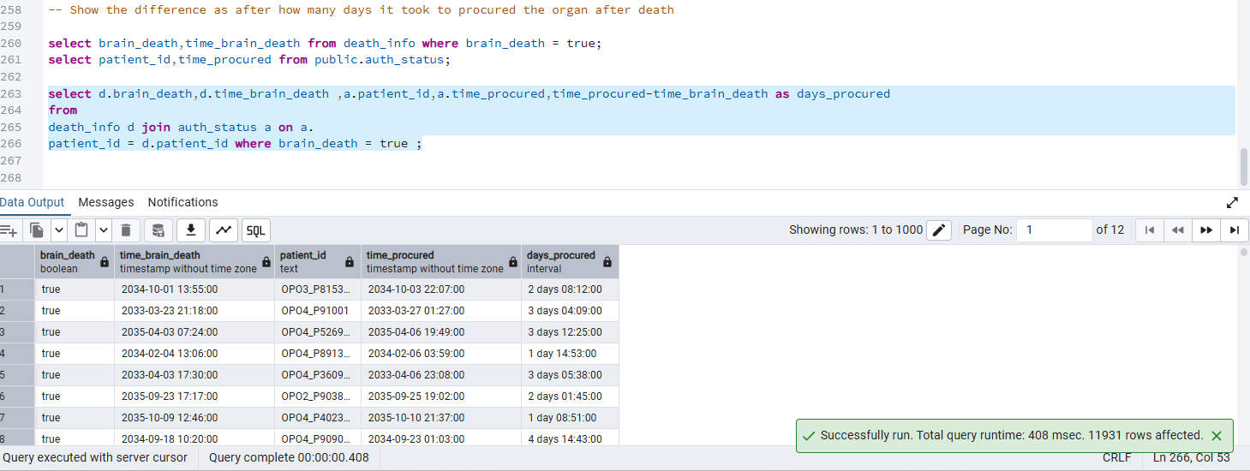

Insight: it shows the time procured from the time of death to procured by using the joins and date time.

25. How many referrals does each organ type receive?
Reason:
OPOs track organ-specific workload; this is a core operational metric.
Optimization Techniques:
This query is doing grouping + aggregation across eight organ-outcome columns.
GROUP BY can avoid a full table sort and aggregation becomes much faster .
Query:
SELECT outcome_heart, outcome_liver,outcome_kidney_left,outcome_kidney_right,
outcome_lung_left,outcome_lung_right,outcome_intestine,outcome_pancreas, COUNT(*) AS referral_count
FROM referrals
GROUP BY outcome_heart, outcome_liver,outcome_kidney_left,outcome_kidney_right,
outcome_lung_left,outcome_lung_right,outcome_intestine,outcome_pancreas
ORDER BY referral_count DESC;
Output:
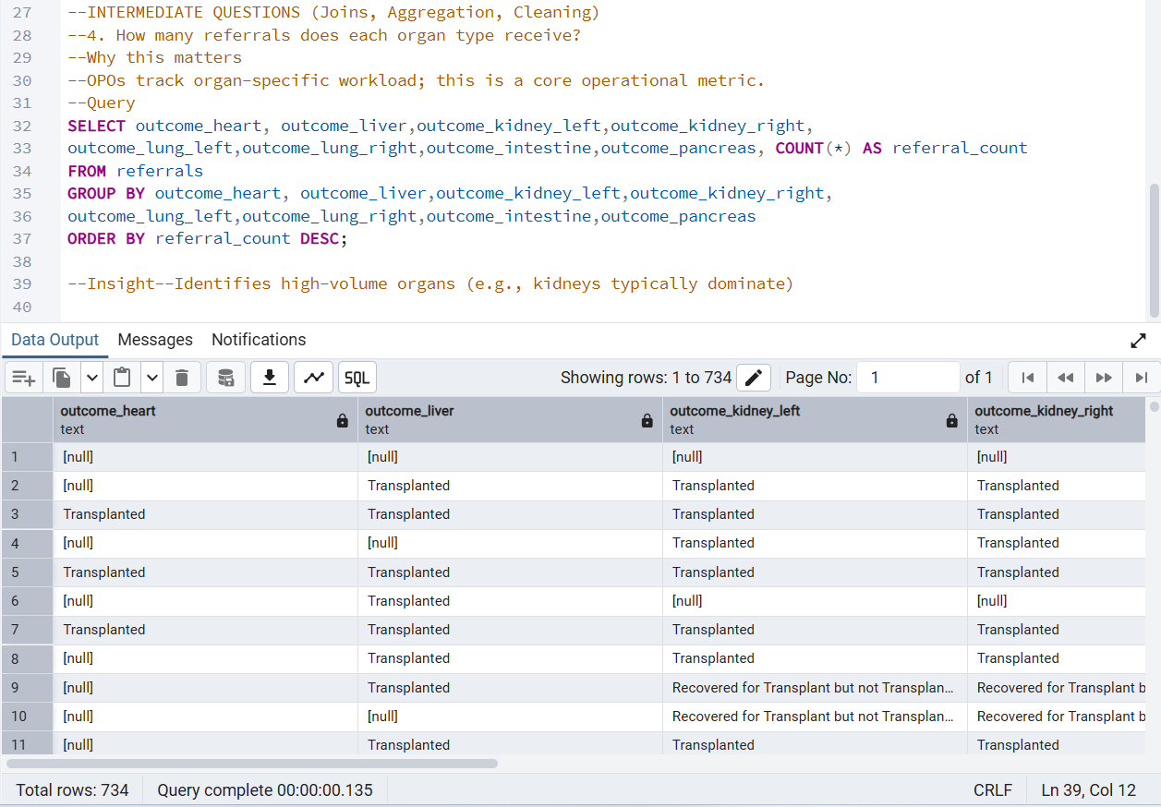
Insight:
Identifies high-volume organs (e.g., kidneys typically dominate)

26. Compare raw vs cleaned referral counts
Reason:
ORCHID includes both raw and cleaned tables; this validates your ETL pipeline.
Optimization Techniques:
This query runs two independent COUNT(*) operations, each scanning a full table
Query:
WITH src AS (
SELECT 'raw' AS type, COUNT(*) AS cnt FROM referrals
UNION ALL
SELECT 'cleaned', COUNT(*) FROM referrals_cleaned
)
SELECT
MAX(cnt) FILTER (WHERE type = 'raw') AS raw_referrals,
MAX(cnt) FILTER (WHERE type = 'cleaned') AS cleaned_referrals
FROM src;

Output:
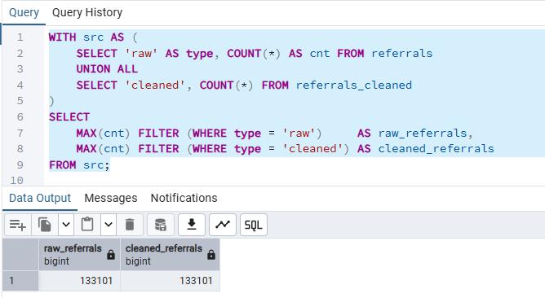

Insight:
Shows how many rows were corrected or removed during cleaning.

27. Identify patients who appear in both patient and calc_deaths
Reason:
Links patient demographics to mortality outcomes.
Optimization Techniques:
This simple inner join create indexes on join keys avoids scanning the entire death_info table and avoids repeated lookups into patient.
Query:
SELECT
patient_id,
opo,
hospital_id,
death_records
FROM (
SELECT
p.patient_id,
p.opo,
p.hospital_id,
COUNT(d.patient_id) OVER (PARTITION BY p.patient_id) AS death_records
FROM patient p
LEFT JOIN death_info d USING (patient_id)
) s
WHERE death_records > 0;

Output:
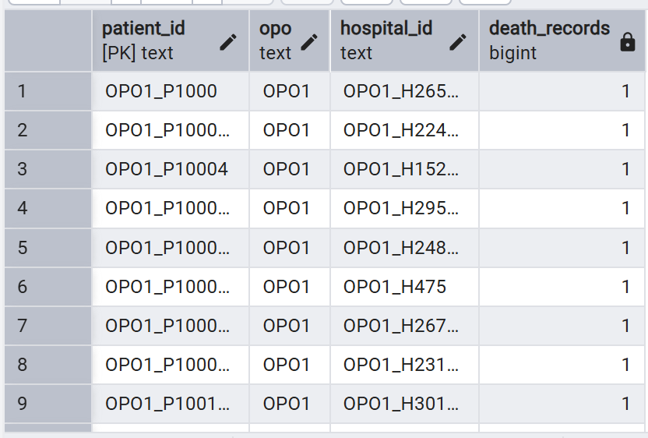
Insights:
How many patients in the system have a documented death record.
Validates Data Integrity Between Patient and Death Tables.

28. Count referrals per patient
Reason:
Some patients generate multiple referrals; this helps identify complex cases.
Optimization Techniques:
This query is doing grouping + aggregation on a potentially large table, and it sorts the results by the aggregated count.
Query:
SELECT *
FROM (
SELECT DISTINCT patient_id FROM referrals_cleaned
) p
CROSS JOIN LATERAL (
SELECT COUNT(*) AS referral_count
FROM referrals_cleaned r
WHERE r.patient_id = p.patient_id
) c
ORDER BY referral_count DESC;

Output:
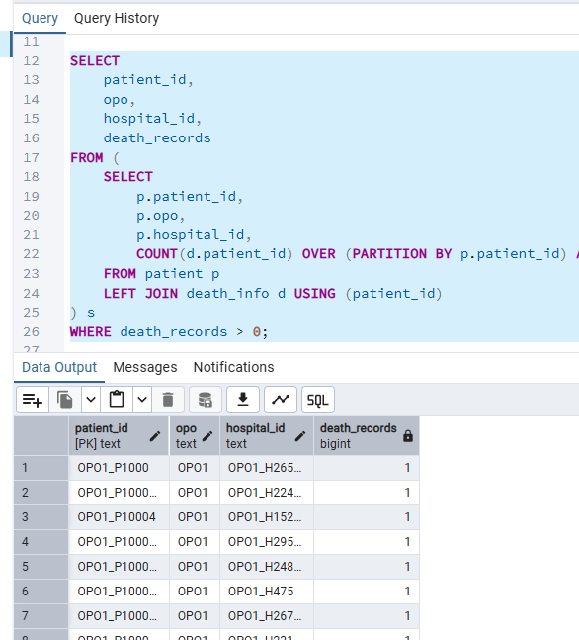
Insight:
Highlights high-utilization patients.

29. Identify patients with no referrals
Reason:
Useful for validating patient–referral linkage completeness.
Optimization Techniques:
This query finds patients who have never had a referral — a classic anti-join pattern. Anti-joins can be expensive if not indexed properly.
Query:
WITH referral_stats AS (
SELECT
p.patient_id,
COUNT(r.patient_id) AS referral_count
FROM patient p
LEFT JOIN referrals_cleaned r
ON p.patient_id = r.patient_id
GROUP BY p.patient_id
)
SELECT patient_id
FROM referral_stats
WHERE referral_count = 0;

Output:
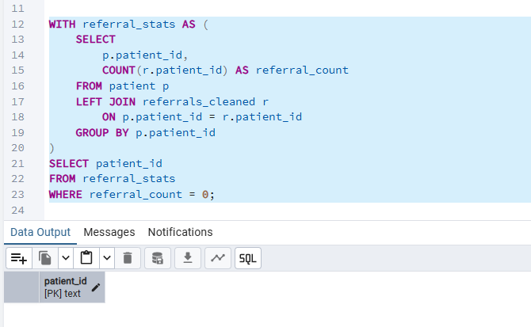
Insight:
Shows orphaned patient records — potential data quality issues

30.Count deaths by mechanism of death
Reason:
Mechanism of death is a key clinical variable used in organ viability assessment.
Optimization Techniques:
It uses group by and order by keeping aggregation minimal and fast
Query:
SELECT
mechanism_of_death,
COUNT(*) AS total,
RANK() OVER (ORDER BY COUNT(*) DESC)
AS rank_position
FROM death_info
GROUP BY mechanism_of_death
ORDER BY total DESC;

Output:
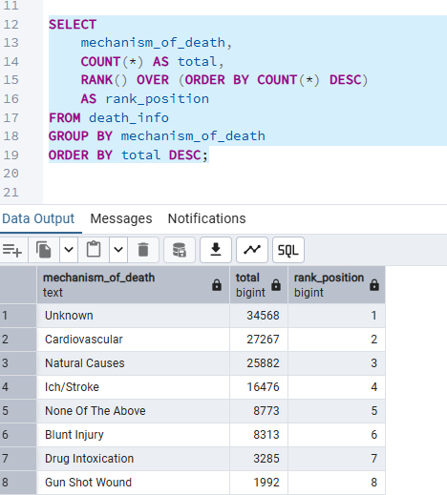
Insight:
Shows which mechanisms (e.g., trauma, stroke) dominate the dataset

